

**Protocol StepByStep-biomechanics**

**Biomechanics analysis of human waking on stairs**

Diego Borro, CEIT

Martxel Eizaguirre, CEIT

**20/10/2021**



This project has received funding from the European Union’s Horizon 2020 research and innovation program under grant agreement No 779963

DOCUMENT HISTORY

|  |  |  |  |
| --- | --- | --- | --- |
| HISTORY OF CHANGES | | | |
| Version | Date | Author | Change |
| 0.1 | 12.03.2021 | Diego Borro | 1st version |
| 0.2 | 20.10.2021 | Anthony Remazeilles | Version with Eurobench format |
| 1.0 | 20.10.2021 | Diego Borro | Added information on data collected |
|  |  |  |  |

Contents

1 Introduction 2

2 Welcome and general experiment explanation 2

3 Place the mocap system (based on IMUs sensors) onto the subject body (lower limbs) 2

4 Mocap calibration 5

5 Detailed explanation of the experiment 6

6 Place the subject at the starting point 7

7 Launch the Data collection software 7

8 Plots 7

9 Perform the experiment (go up and down the stairs = 1 run) 8

10 Stop the data collection when the subject arrives at the initial position 8

11 Repeat the procedure starting at step 5, to reach 5 runs. 9

12 In case of opening a previous recording for postprocessing 9

# Introduction

This document describes the protocol enabling to characterize the biomechanics of human while walking on stairs. The following sections describes the main steps of the data acquisition process.

This protocol was created in the context of the sub-project StepByStep, funded by Eurobench.

# Welcome and general experiment explanation

When the subject arrives to the facilities, the leader of the experiment will give him/her a general explanation of the experiment including:

* Presentation of the adjustable stairs (experimental setup)
* Explanation of the motion capture system
* Explanation of the exoskeleton
* Explanation of all the motions to be performed

# Place the mocap system (based on IMUs sensors) onto the subject body (lower limbs)

Take in consideration that to begin the process, you will have two choices: capture the movement or perform the post processing. You are only allowed to perform post processing on previously recorded scenarios. So, the first step is to capture the movements.

1. We are currently working with Perception Neuron PRO Mocap. The sensors from now on called Neurons, included on this set looks like this one:

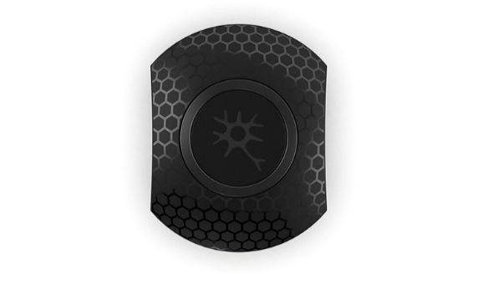

1. There are 17 neurons located on a suitcase. These neurons are wireless, so take in consideration they should be charged each 6 hours at most. To charge them, just place them on the suitcase, making sure that you press them on each position until click. Then connect the suitcase to the power supply. It should look as follows:

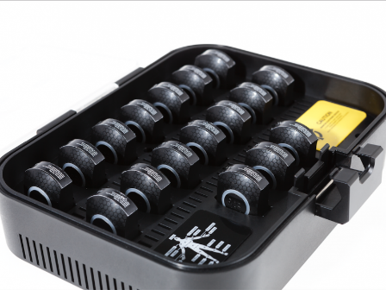

1. When using the neurons, take in consideration that in the rear, they have an indication of which part they track. Is important to place each neuron on its correct limb. The neurons should be placed on a stripe as seen on this picture:

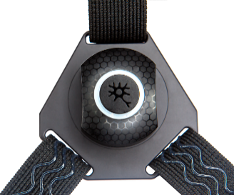

1. Approximately, one sensor should be placed in each of the following locations (**for right and left leg**):
   1. Thigh, lateral aspect, mid point between the knee joint center and hip joint center
   2. Shank, lateral aspect, mid point between the ankle joint center and knee joint center
   3. Foot, instep center
   4. Pelvis, between L5 and sacrum

A total of 7 sensors should be placed, 3 per leg and one on the pelvis.

1. Consider that the Neurons on the thighs should be placed on a lateral, while the knee and foot should face front. Check the following picture:

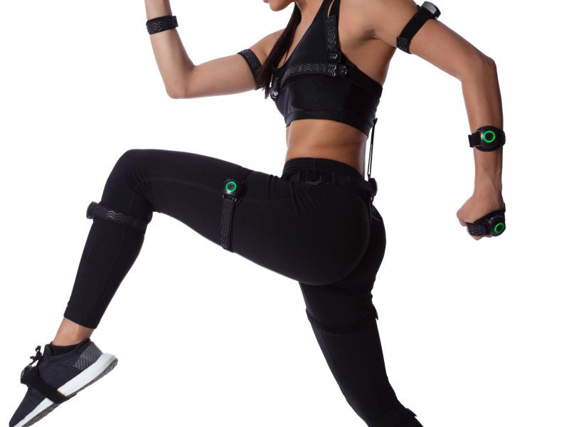

1. After the positioning is completed, turn on the Neurons one by one. To do so, just press on each one for about 3 – 5 seconds. The lights on the Neurons should turn on green color and flash each 3 seconds.
2. Then, plug the hub receiver to an USB port on your computer.

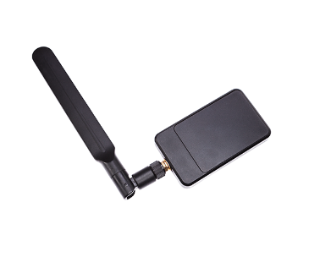

1. Open the axis neuron pro software, at first it will have a splash screen as can be seen on the following picture:

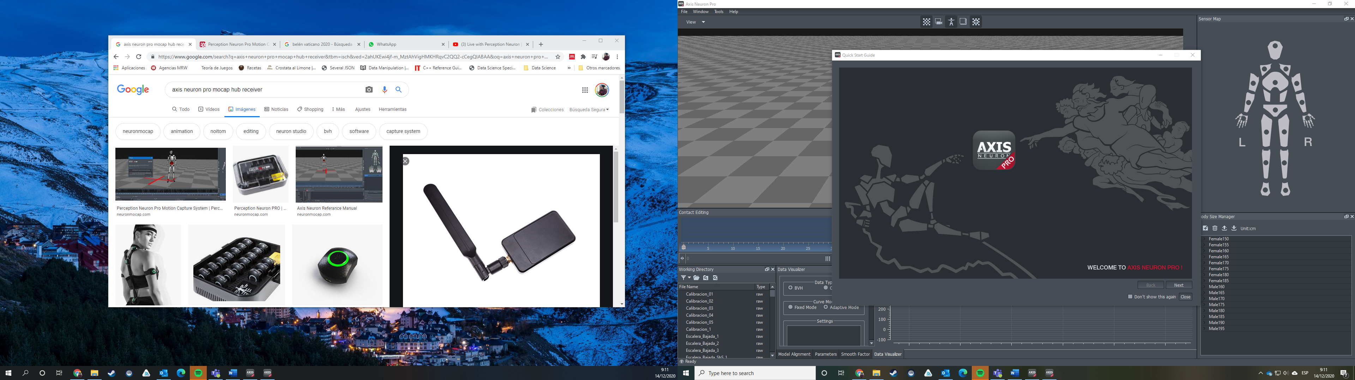

1. Close the splash screen and a new subscreen will appear. It allows you to connect to the receiver hub (stablish connection with the Neurons) or open a previously saved capture.

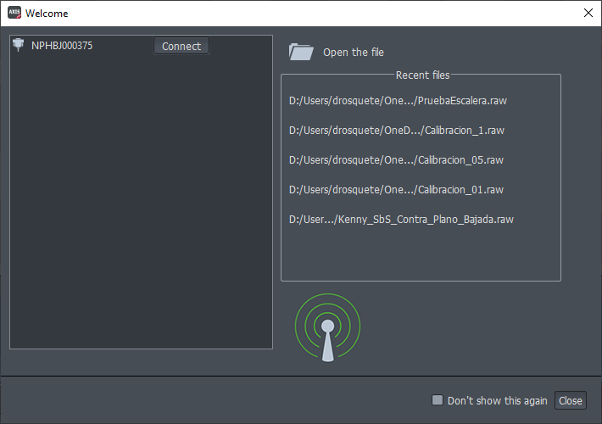

1. Click on connect as seen on the previous screen. Then you should see the avatar on the screen, probably it will be with a bad posture, not reflecting the reality. First, you should indicate gender and height of the person. Take in consideration that this panel is located on the right side of the screen as can be seen on the 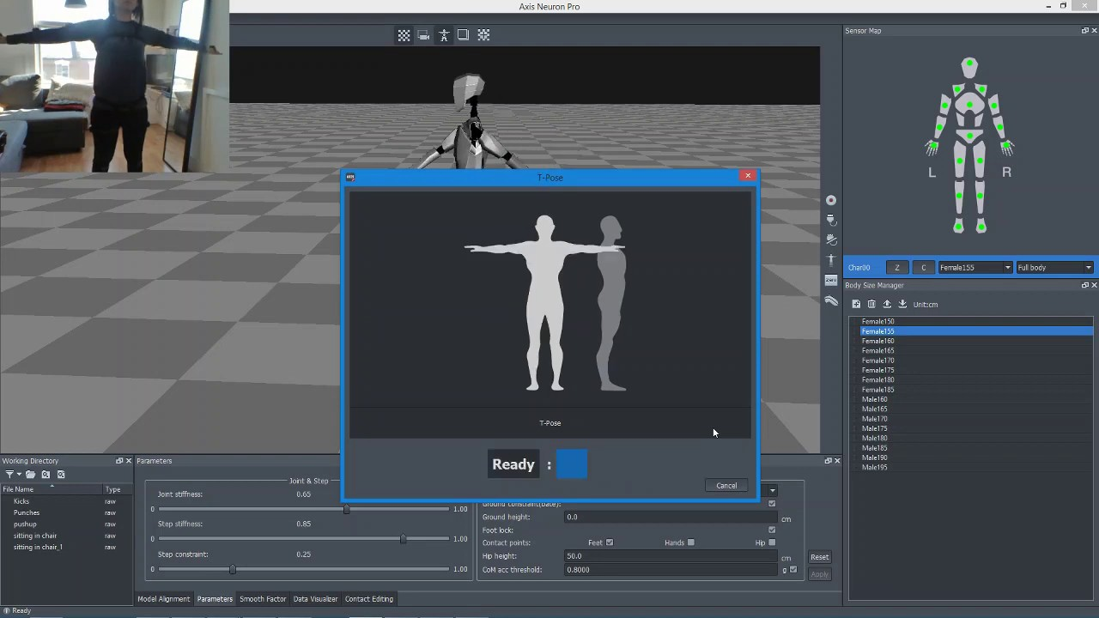picture.

# Mocap calibration

1. After checking the gender and height, you must calibrate the sensors. To perform this operation, all you need to do is click on the calibration button as shown below on green.

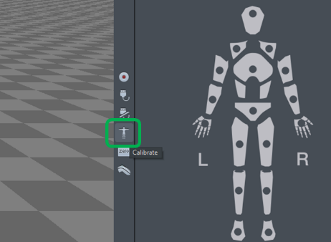

1. Now it will ask for the person wearing the suit to perform 4 postures.
   1. The first one is sitting in front of a table with the hands on top (optional).
   2. The second is standing still with arms next to legs.
   3. The third is performing a T position, arms wide open and legs extended.
   4. Finally, the fourth is S position, the knees should be bended about 45 degrees and the arms fully extended in front of the person.

Each position takes about 5 seconds to calibrate. In case you are not satisfied with the avatar, please check the sensors are on the right position and recalibrate with the same button.

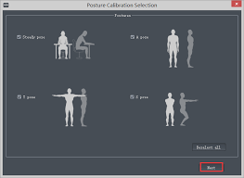

# Detailed explanation of the experiment

At this point, the experimenter will give a detailed explanation of the experiment to the subject. The experiment consists on ascending and descending the stairs.

1. Ascending stairs. The subject will ascend the stairs step by step.
   1. The subject will stand (5 seconds) with both feet next to each other at a distance from the first step such that the first steep can be steeped comfortably
   2. The subject will start ascending the stairs when he/she receives a signal from the experimenter
   3. The pace of climbing will be chosen by the exoskeleton
   4. When the subject reaches the last step, he/she will place both feet next to each other looking forward in the direction of climb (5 seconds). The subject will remain in this posture until he/she receives a signal from the experimenter
2. Descending stairs. The subject will descend the stairs step by step.
   1. The subject will turn around 180º degrees
   2. The subject will stand (5 seconds) with both feet next to each other at a distance from the first step such that the first steep can be steeped comfortably
   3. The subject will start descending the stairs when he/she receives a signal from the experimenter
   4. The pace of descending will be chosen by the exoskeleton
   5. When the subject reaches the floor, he/she will place both feet next to each other looking forward in the direction of descend (5 seconds). The subject will remain in this posture until he/she receives a signal from the experimenter

Additional instructions could be given depending on the chosen experiment. For example, If the handle can be grabbed or not or the number of repetitions for each type of motion.

# Place the subject at the starting point

The subject will stand with both feet next to each other at a distance from the first step such that the first steep can be steeped comfortably.

# Launch the Data collection software

* + - 1. Once you are ready and calibrated, one last step is needed before recording. Look for the panel located at the bottom of the screen. Click on the tab named “Parameters” and make sure the checkbox “feet” is checked.
      2. Every time you want to make a new measurement, you must calibrate the subject with respect to the ground. To do this, the "Ground constraint (bate)" box will be checked and unchecked before each recording.

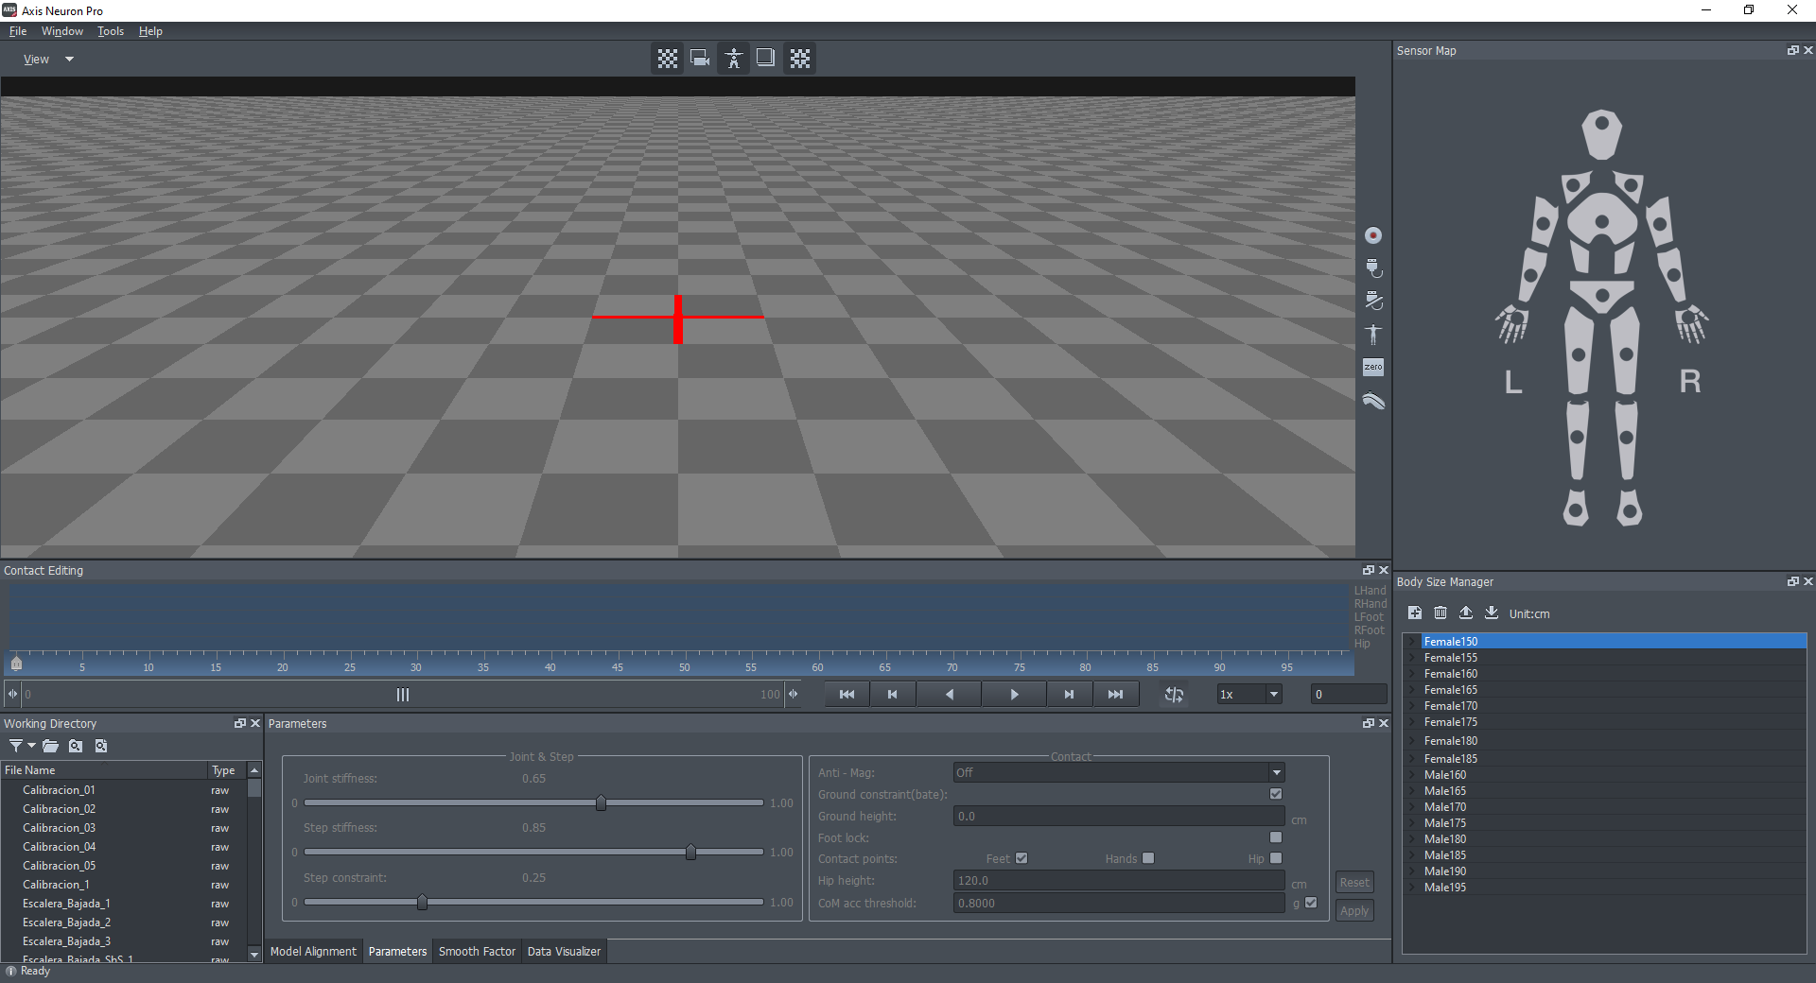

* + - 1. Click on record

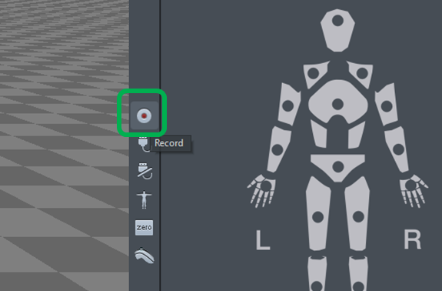

* + - 1. It will ask you the name of the file and if you are sure, fill this information.

# Plots

If you want to plot the different metrics of the subject, go to the "Data Visualizer" tab. Here you can view both with recorded files and in real time the different metrics of the body parts. You just have to check the settings you want to visualize.

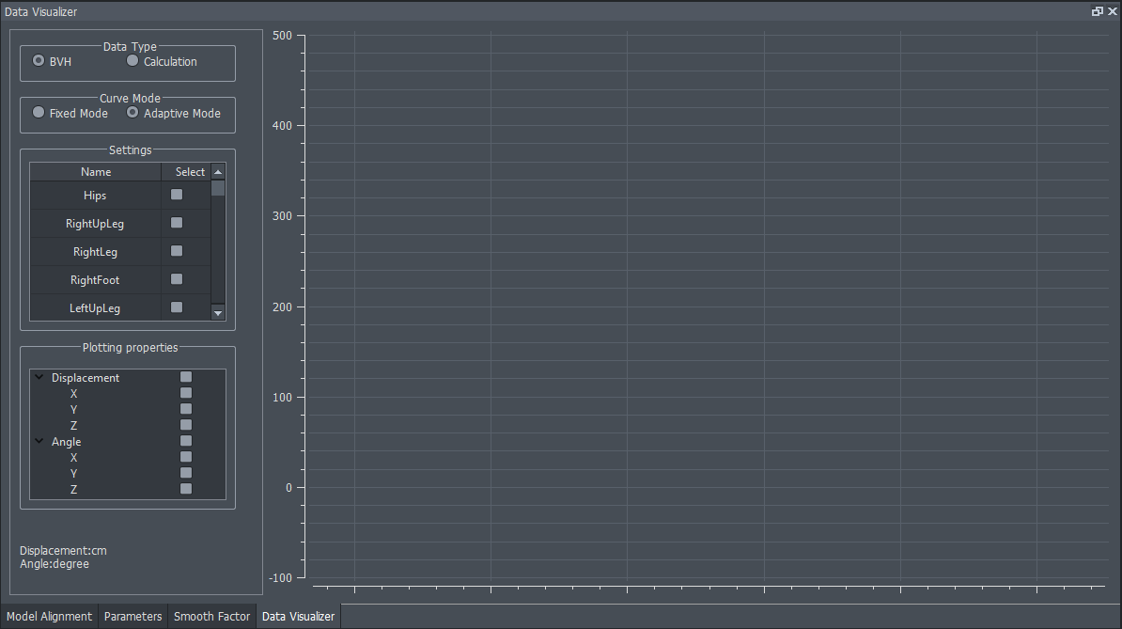

# Perform the experiment (go up and down the stairs = 1 run)

The experimenter is responsible for counting the 5 seconds (described in Section 4) and warning the subject to start moving.

# Stop the data collection when the subject arrives at the initial position

And as soon as your capture is finished, click on the same button of record, now it changed and means stop.



# Repeat the procedure starting at step 5, to reach 5 runs.

|  |  |  |
| --- | --- | --- |
|  |  | Time (minutes) |
| 1 | Welcome and general experiment explanation | 5 |
| 2 | Place the mocap system | 5 |
| 3 | Mocap calibration | 2 |
| 4 | Detailed explanation of the experiment | 3 |
| 5 | Place the subject at the starting point | - |
| 6 | Launch the Data collection software | - |
| 7 | Perform the experiment (1 run) | 0.5 |
| 8 | Stop the data collection | 1 |
| 9 | Repeat the procedure starting at step 5, to reach 5 runs | 7.5 |
|  | **Total (Stages 1+2+3+4+9)** | **22.5** |

*Summary of timing in every single experiment stage*

# In case of opening a previous recording for postprocessing

1. Open the application regularly. You will see the following screen.

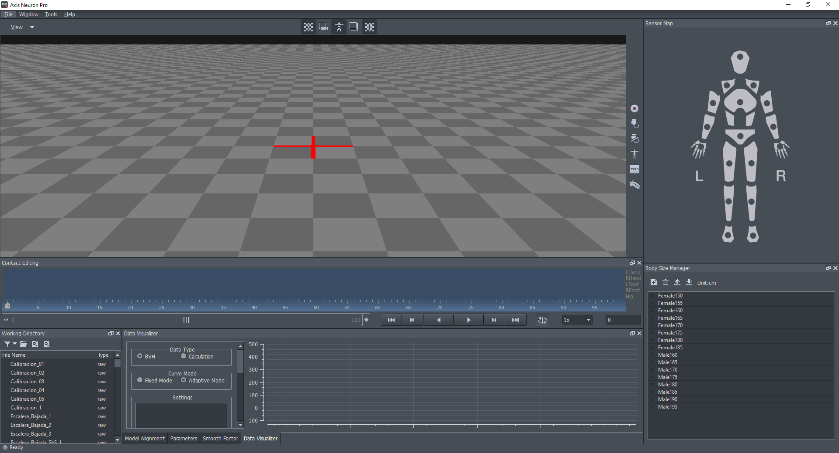

1. Check on the lower left panel “Working Directory” that you have access to all the raw files you previously captured. If is empty change the working directory.

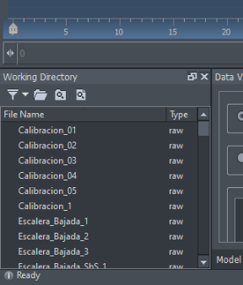

1. Double click on the sample you want to analyze. The avatar will display on the screen and the frames will be filled with blacks and grays indicating the contact points. Then verify it is correctly loaded by clicking play button on the screen.

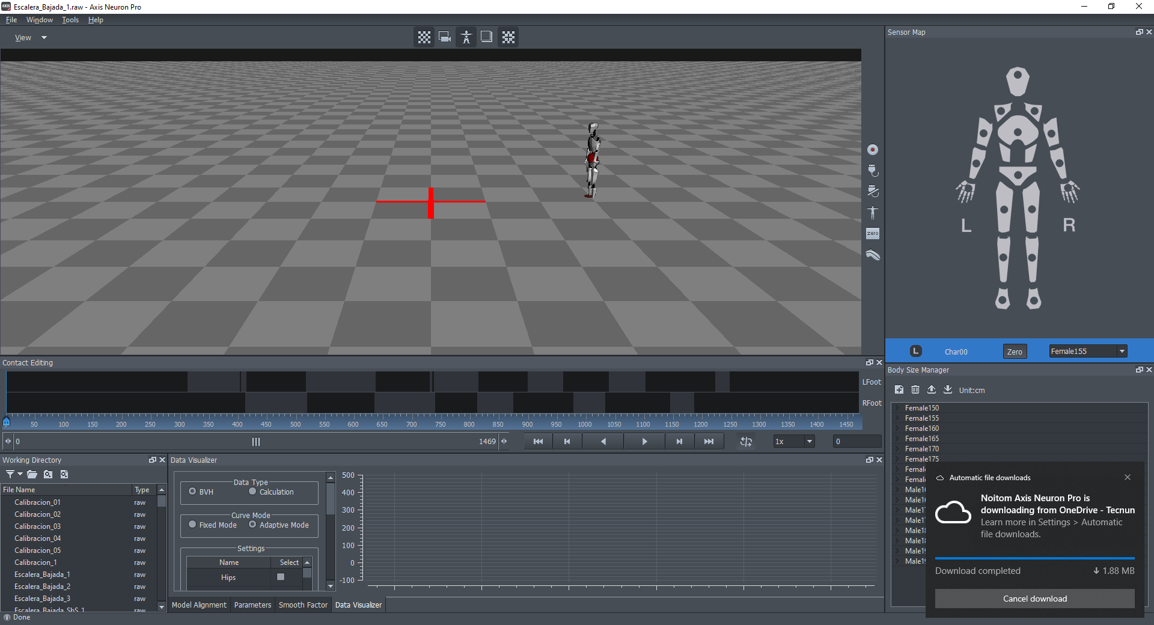

1. (Optional, only if you changed something on Settings) Verify your IP address and port. The steps to check are in the following order, open settings and it will show on the sixth screen the ports, the data stream port should be 8012. After checking, click close:

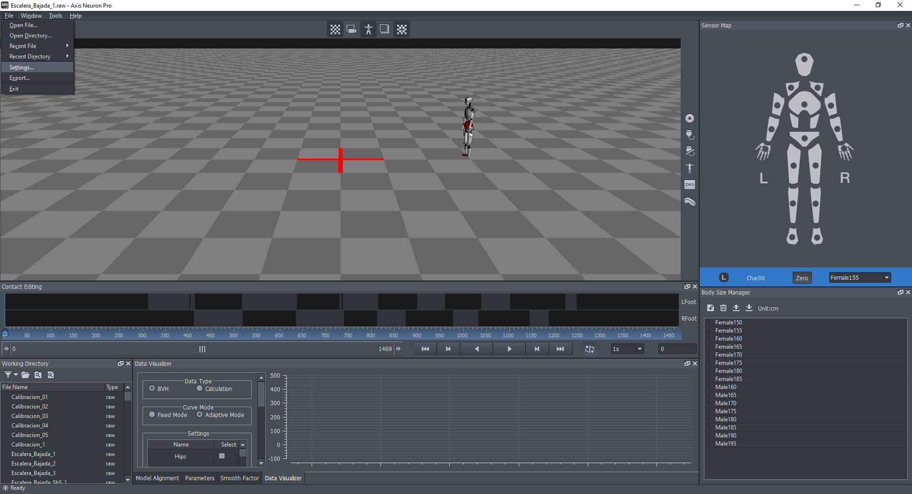

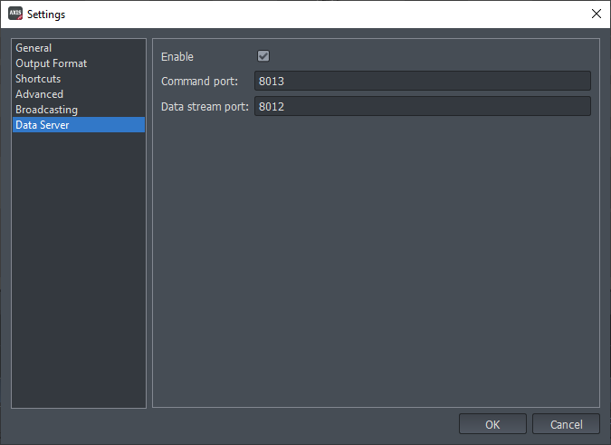

1. Verify the Output Format that must be "XYZ":

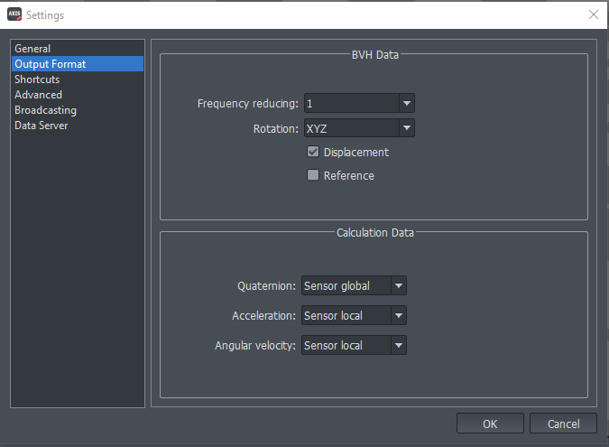

1. Open the python command prompt on the repository folder “Connection” and execute the following line:

python connect.py

1. Click play on Axis neuron pro. The python command prompt will display a 64 that is indicative of a correct transmission. As soon as the axis finishes the transmission, the prompt will save a CSV named platformData.csv.

**BE CAREFUL**: as the experiment have 5 runs, after step 7 you should rename each csv file following this indication:

*run_Z_platformData.csv*

*Z* is an integer (01, 02, 03, 04, 05) depending on the number of run you want to execute.

1. In the anaconda prompt, move to the “PI_Algo” folder and execute the following line (detailed instructions are on the gitHub website[1]):

python run_protocol_1.py sample_file_fullpath output_directorypath

replacing the *sample_file_fullpath* field with the path of the csv file that you previously saved.

1. In the output directory, 25 yml files will appear. They are all metrics related to Gait Phases of ascending and descending following next figures:



Ascent motion:

* Stance phase:
  + **Weight acceptance** (WA). It is initiated with the middle to front portion of the foot. The remainder of weight acceptance involved movement of the body into an optimal position to be pulled up to the next step.
  + **Pull-up** (PU). from the beginning of single leg support to approximately mid-swing of the contralateral leg.
  + **Forward continuance** (FCN). By mid-swing of the contralateral leg, the subject had fully ascended one step and continued forward to the next step. From this point to the end of ipsilateral stance mostly forward motion was observed, with some lift prior to toe-off. This phase was referred to as forward continuance.
* Swing phase
  + **Foot clearance** (FCL) along with simultaneous lifting of the swing leg. This subphase involves not only bringing the leg up and over to the next step, but also keeping the foot clear of the intermediate step. This is accomplished in two ways. First, the toe was lifted through dorsiflexion by the tibialis anterior. Second, the leg was pulled back through flexion at the knee.
  + **Foot placement** (FP).

Descent motion:

* Stance phase:
  + **Weight acceptance** (WA). From right foot contact (36% of stride as shown) to left toe-off.
  + **Forward continuance** (FCN). From left toe-off (commencement of single right leg support) to mid-swing of left leg.
  + **Controlled lowering** (CL). From mid-swing of left leg until right toe-off.
* Swing phase:
  + **Leg pull through** (LP). From right toe-off to mid-swing of right leg.
  + **Foot placement** (FP). From mid-swing of right leg until right foot contact.

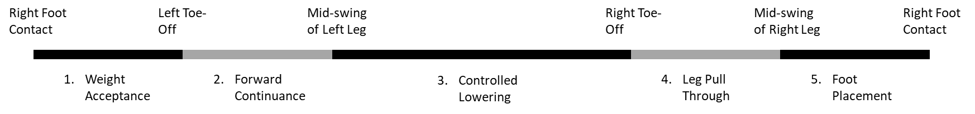

In summary, these are the computed metrics:

|  |  |
| --- | --- |
| **Ascending** | **Descending** |
| ascending_total_time | descending_total_time |
| ascending_weight_acceptance | descending_weight_acceptance |
| ascending_pull_up | descending_forward_continuance |
| ascending_forward_continuance | descending_controlled_lowering |
| ascending_push_up | descending_swing_leg_pull_through |
| ascending_swing_foot_clearance | descending_swing_foot_placement |
| ascending_swing_foot_placement |  |
| ascending_hip_left_angle | descending_hip_left_angle |
| ascending_knee_left_angle | descending_knee_left_angle |
| ascending_ankle_left_angle | descending_ankle_left_angle |
| ascending_hip_right_angle | descending_hip_right_angle |
| ascending_knee_right_angle | descending_knee_right_angle |
| ascending_ankle_right_angle | descending_ankle_right_angle |

The collected experimental files (considered as *pre-processed files*), i.e *run_Z_platformData.csv* can be uploaded to the Eurobench website for getting the experiment and the benchmark output registered.

Note that, if the experiment is done with several subjects, the data file should be named:

*subject_N_run_Z_platformData.csv*

If the stair configuration is changed, or any condition setting is adjusted, we would expect to get files named as follows:

*cond_C_run_Z_platformData.csv* or *subject_N_cond_C_run_Z_platformData.csv*

Even if not used for the metric computation, it is good practice to store the information of the different settings in files named *condition_C.yaml* to be able a posteriori to remind what were the exact conditions of experimentation.

# Experimental data **collected**

The translation and rotation data of the different neurons is collected into the platformData.csv file. These neuron data are calculated relative to the main neuron, the hip neuron. The frequency of obtaining the data is 120 frames per second.

The following will explain the abbreviations of the headers used in the platformData.csv file.

Except for the first column that expresses the frame index, all the other columns follow the same label pattern: Label-M_C

Where "Label" is the abbreviation of the part of the body where the neuron is located, "M" the type of movement and "C" the Cartesian coordinate.

"Label" can have the following values:

* Hips: Hips
* RUL: Right Up Leg
* RK: Right Knee
* RF: Right Foot
* LUL: Left Up Leg
* LK: Left Knee
* LF: Left Foot

"M" can refer to two different metrics:

* T: translation. Unit is meter.
* R: rotation. Unit is Euler Angle.

"C" is the Cartesian coordinate that takes three different values:

* X
* Y
* Z

1. <https://github.com/eurobench/pi_sbs_biomechanics>